**Financial Options**

**Call & Put Options**

# Option Contracts

* Owner has the Right (Not obligation) to trade an asset at a fixed price on *or before* a fixed future date

|  |  |
| --- | --- |
| **Keyword** | **Explanation** |
| **Owner** | **Buyer** is known as the **Option Holder**  **Seller** is known as the **Option Writer**  Option Holder pays Option Writer a **Premium** at time 0 |
| **Right (Not Obligation)** | **Option Holder** has the **Right to Exercise** the Option  **Option Writer** is **Obligated** to fulfil the trade |
| **Trade an Asset** | Right to **Buy** an asset is a **Call Option**  Right to **Sell** an asset is a **Put Option** |
| **Fixed Price**  **Fixed future date** | Fixed price is known as the **Strike Price**  Fixed future date is known as the **Expiration Date** |
| **Before or on** | **American Options** → **Any time** before or on **Bermudan Options** → During a **specific window** before **European Options** → **Only on** expiration |

**Other information**

* 
* European and American options will be distinguished by **Small & Capital Letters**
* Options will only be exercised if it is **favourable** to do so **(Positive Payoff)**

# European Call Options

## Long Calls

|  |  |
| --- | --- |
| **Exercise** | **Don't Exercise** |
| **Cheaper** to buy via the Call | **More expensive** to buy via the Call |
| Spot Price is **Larger** than the Strike Price | Spot Price is **Smaller** than the Strike Price |
| Payoff is the difference in Spot and Strike | NO payoff since no trade occurs  *Payoff = 0* |
| Profit is the difference in Payoff and Premium | Profit is the difference in Payoff and Premium |

We can represent Options using a **Piecewise Function** or **Maximum Function**:







* Options will only be exercised if there is a **Positive Payoff**
* But Positive Payoffs does **NOT** guarantee a **Positive Profit**

|  |  |
| --- | --- |
| **Maximum** | **Minimum** |
| Occurs when option IS exercised | Occurs when the option is NOT exercised |
|  | Minimum payoff is 0 |
|  |  |
| **Unlimited Upside** | **Limited Downside** |

Payoff 
Profit 
Spot Price 
-AV(C) 
Spot Price 

## Short Calls

* Using the Zero-Sum Game property, the short position is simply the opposite of the Long one







|  |  |
| --- | --- |
| **Maximum** | **Minimum** |
| Occurs when option IS NOT exercised | Occurs when the option IS exercised |
| Maximum payoff is 0 |  |
|  |  |
| **Limited Upside** | **Unlimited Downside** |

Payoff 
Profit 
AV(C) 
Spot Price 
Spot Price 

## Long Puts

|  |  |
| --- | --- |
| **Exercise** | **Don't Exercise** |
| **Earn more** by selling via the Put | **Earn less** by selling via the Put |
| Spot Price is **Smaller** than the Strike Price | Spot Price is **Larger** than the Strike Price |
| Payoff is the difference in Spot and Strike | NO payoff since no trade occurs  *Payoff = 0* |
| Profit is the difference in Payoff and Premium | Profit is the difference in Payoff and Premium |

We can represent Options using a **Piecewise Function** or **Maximum Function**:







* Options will only be exercised if there is a **Positive Payoff**
* But Positive Payoffs does **NOT** guarantee a **Positive Profit**
* Notice that this is the opposite of a Call as the perspective has been flipped to **Selling instead**

|  |  |
| --- | --- |
| **Maximum** | **Minimum** |
| Occurs when option IS exercised | Occurs when the option is NOT exercised |
| Maximum payoff is K | Minimum payoff is 0 |
|  |  |
| **Higher Upside** | **Lower Downside** |

## Short Puts

* Using the Zero-Sum Game property, the short position is simply the opposite of the Long one







|  |  |
| --- | --- |
| **Maximum** | **Minimum** |
| Occurs when option IS NOT exercised | Occurs when the option IS exercised |
| Maximum payoff is 0 |  |
|  |  |
| **Lower Upside** | **Higher Downside** |

Payoff 
-K 
Profit 
Spot Price 
Spot Price 

# Comparing Long and Short Positions

|  |  |
| --- | --- |
| **Long Position** | **Short Position** |
| Non-Negative Payoffs  NO Default Risk | Non-Positive Payoffs  Default Risk present |
| No Margin Required | Margin Required  No need for Covered Positions |
| Higher Upsides  Lower Downside  Seemingly better | Lower Upsides  Upside Downside  Seemingly worse |
| Low probability of exercise  Lose often but occasionally win big | High probability of NO exercise Win often but occasionally lose big |

# Option Moneyness

* It is the long payoff of the option if it were to be **exercised immediately** at the **current spot price**
* It is a **notional** indicator; it does not mean the option SHOULD (NOT) be exercised
* It is meant to give an indication about the current spot price without having to give the exact value

|  |  |  |
| --- | --- | --- |
|  | **Calls** | **Puts** |
| **In the Money (ITM)** | Positive Payoff | Positive Payoff |
| **At the Money (ATM)** | Zero Payoff | Zero Payoff |
| **Out of the Money (OTM)** | Negative Payoff | Negative Payoff |

An easy way to compare "moneyness" of options to consider their **payoff graphs on the same diagram**

**European Option Put Call Parity**

# European Put Call Parity

* It is a **relationship** which equates the difference in European Call and Put **Premium** to the difference of the underlying asset's *Prepaid Forward Price* & the Present Value of its Strike Price
* Note that it refers to the **initial cashflow** thus the perspective of buying and selling should be from the **initial time** rather than at maturity (Payoff)
* 

## No Arbitrage Proof

* Consider two portfolios with the same payoff:
  + Long Forward
  + Long Call & Short Put
* Assuming the Law of One Price, both these portfolios must be **priced the same**







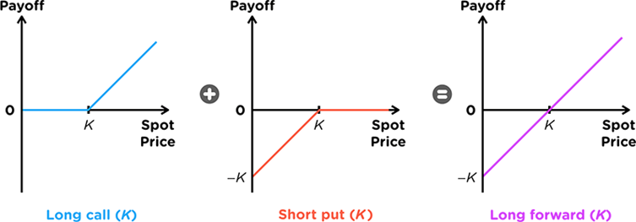

The price of the portfolio at of the two options at time 0 is simply the **difference in premiums**:

* Pay premium for the Long Call
* Receive premium for the Short Put



 The price of the Long Forward at time 0 is **complicated** to determine:

* We usually pay the Forward Price at time T, thus we need to adjust it to find the cost at time 0
* The payoff of a Forward Contract involves:
  + 
  + 
* We consider a replicating portfolio:
  + To replicate buying the asset at a **fixed** price, we **sell a Zero Coupon Bond**
  + To replicate selling the asset at the future spot, we **buy a Prepaid Forward**



## Prepaid Forward Price

* It is a contract which delivers the underlying at maturity, but is **paid for at time 0**
* The price of a prepaid forward is simply the **PV of the Forward Price**
* Since there are different variations of the Forward Price based on the underlying, there are different variations of the Prepaid Forward as well:



Prepaid Forward Price (1%) Forward Price (Fo) 
No Dividends 
Discrete Dividends 
Continuous Dividends 
so - PV(Dividends) 
So — AV(Dividends) 
So • 

Note that if the Discrete Dividends **occur after the expiry**, then we can ignore them

## Put Call Parity for Comparison

* Due to the no arbitrage nature of PCP, it is commonly used to determine the relative values of Options or related assets
* Although it is common sense to read an inequality, it can be stressful to interpret inequalities under exam settings
* Thus, there is an easy method to read them:







Based on the sign of the additional terms, we replace the equal sign with an inequality,

|  |  |
| --- | --- |
| **Additional Terms are Positive** | **Additional Terms are Negative** |
|  |  |

# Synthetic Positions

* Note that put call parity uses a **Cashflow Perspective** at time 0:
  + **Negative Cashflow** → Cash outflow → Buy
  + **Positive Cashflow** → Cash Inflow → Sell
* By **re-arranging the equations** to match the **initial cashflow** of any position on the LHS, the RHS will produce the initial cashflow of **any replicating portfolio**

**Common Synthetic Positions**

Symthetic Position 
Long 
-co = -po + Ke 
Put 
-po — —co - + 
Kerr —po + co — Fop 
Treasury 
FOP SO 
Non-Dividend Stock 
—SO ¯ 
Dividend Stock 
Continuous Dividend 
—So 
CO - + PO 
— so - PV(D) 
+ PO + PV(D) 
Soe¯rq 
—So — Ke-rt + PO) 
Short 
co = po — Ke-rt + FOP 
¯ ¯ FOP 
Kerr = po — co + FOP 
so-co + Ke-rt —po 
FOP —so — PV(D) 
so + —po + PV(D) 
FOP Soe—rq 
so erq(co + Re-rt — PO) 

# Multiple Put Call Parity

* If you are given Option prices at different dates but with the **SAME MATURITY**, then PCP can be used to solve for the risk free rate







**Early Exercise of American Options**

# Early Exercise Condition

* The option will be exercised early **if it is more valuable to do so**
* There are two main benefits of each option:
  + Receiving Dividends
  + Investing the Strike
* Thus, we compare the PV of the above two values to decide if it should be exercised
  + 
  + 

|  |  |  |
| --- | --- | --- |
|  | **Exercise Early** | **Exercise Later** |
| **Long Calls** | Buy the stock now  Own the Stock  **Receive Dividends** | Buy the stock later  Save K  **Invest the amount** |
| **Long Puts** | Sell the Stock now    **Invest the amount** | Sell the stock later  Own the Stock  **Receive Dividends** |

## PV of Interest









## PV of Dividends

Consider the formula for the Prepaid Forward,







* Thus, by substituting the correct formula for the Prepaid Forward based on Discrete/Continuous Dividends, we can obtain the PV of dividends

## PV of Insurance

* Apart from receiving dividends and investing, another consideration is price movements of the asset
  + **Calls** → Risk of **price falling** immediately after exercising
  + **Puts** → Risk of **price rising** immediately after exercising (Opportunity Cost)
* These risks are present even if we exercise later; but we can minimize these risks **between the period of early exercise and maturity**
* We can value the protection by using options:
  + Protection against price falls → Put Options
  + Protection against price rises → Call Options
  + Note that the Insurance is always an **European Option**

|  |  |  |
| --- | --- | --- |
|  | **Exercise Early** | **Exercise Later** |
| **Long Calls** | Buy the stock now  **Risk of price fall** | Buy the stock later  **No risk of price fall** |
| **Long Puts** | Sell the Stock now  **Risk of price rise** | Sell the Stock Later  **No risk of price rise** |

## Proper Early Exercise Condition

* If one side is higher than the other, then we perform the action on that column

|  |  |  |
| --- | --- | --- |
|  | **Exercise Early** | **Exercise Later** |
| **Long Calls** | **Receive Dividends** | **Interest on Strike**  **Implicit Put** |
| **Long Puts** | **Interest on Strike** | **Receive Dividends Implicit Call** |

# Timing of Exercise

* Dividends are recognised as a **loss of capital** from the company thus the price of the stock will **fall by an amount equal to the dividend**
  + Call Payoffs are **directly proportional** to stock prices thus **should not experience** this price drop
  + Put Payoffs are **inversely proportional** to stock prices thus **should experience** the price drop
* Thus, if the option was going to be exercised early,
  + **Calls should be exercised right BEFORE** dividends are paid
  + **Puts should be exercise right AFTER** receiving dividends

# Non-Dividend Assets

* Based on the Early Exercise Condition, **higher dividends** increase the likelihood of early exercise of **Calls** and decreases the likelihood of **early exercise of Puts**
* For an asset with no dividends,
  + American Calls will **NEVER** be exercised early
  + American Puts **SHOULD (Not Guaranteed)** be exercised early
* Thus, an American Call whose underlying does not pay dividends is **identical to an European Call**
  + This application can be extended to cases where the underlying pays a **small dividend** - once it is confirmed that the option will not be exercised early, we can treat it as a European one

**Option Price properties**

# Lower Price Bounds

## Non-Negative Payoffs

* Option Holders will ONLY exercise the option for a positive payoff
* Conversely, Option Writers will ALWAYS have a negative payoff
* To compensate the Option Writer for bearing this risk, they will always charge a positive premium





## European No Arbitrage

* European Options MUST abide by **Put Call Parity** to avoid Arbitrage









## American No Arbitrage

* American Options are NOT bound by the Put Call Parity
* Since they can be exercised at any point in time, the cost of the option cannot be lesser than the immediate exercise value (**Cannot buy & sell immediately for profit**)





## Putting it all together

* Combining the above two conditions, we can express the lower bound in the form of a maximum function
* Notice that the lower price bounds are **identical to payoff graphs for an option**









# Upper Price Bounds

## European Best Case Scenario

* Upper price bounds are determined by considering the **Best Case Scenarios & Replicating Portfolios**
* We cannot use the Law of One Price to determine the lower limit - but we can apply a similar logic
* It **does NOT make sense** to pay a higher price for a lottery (Option) compared to the price for a guaranteed Best Case Scenario Replicating Portfolio









## American Best Case Scenario

* Since American Options can be exercised early, we consider the Immediate Exercise Value instead
* We would NOT pay to enter a contract with a lower maximum payoff than the cost to enter it









## Putting it all together

* Notice that the lower price bounds are **identical to payoff graphs for a Stock or Bond**









## European VS American Options

* American Options can do everything that a European Option can
* American Options have the **added flexibility** of being exercised early which can result in better payoffs
* Thus, American Options must be priced at least as much as European Options





# Combining Upper & Lower Bounds









|  |  |  |  |
| --- | --- | --- | --- |
|  | **Lower Bound** | **Upper Bound** | **Image** |
| **European Call** |  | Stock | II |
| **American Call** |  | Stock | I |
| **European Put** |  |  | IV |
| **American Put** |  |  | III |

x—S-100 
95.12 

# 

# 

# Strike Price Condition

* 
* Based on the relative strike prices, we can form conclusions about the Option Prices **based on no arbitrage arguments**

## First Proposition: Option Prices and Strike Prices

* Call Payoffs are inversely related to the Strike Price
* Put Payoffs are directly related to the Strike Price
* Options with **higher payoffs must cost more** than an option with a lower payoff





## Second Proposition: Difference in Option Prices and Strike Prices

* All else equal, the difference in Payoff is the difference in Strike Prices
* The ***maximum* difference** in the price should be the difference in Payoff/Strike Prices
  + American Options can directly use the difference since they can be exercised immediately
  + **European** Options should use the **present value** of the difference









## Third Proposition: Rate of Change in Option Prices

* **Call prices decreases slower** relative to the change in Strike Prices
  + **Gradient decreases** with respect to Strike Prices → Convex Curve
* **Put Prices increase faster** relative to the change in Strike Prices
  + **Gradient increases** with respect to Strike Prices → Concave Curve









C(K2) 
C(K3) 
P(KJ) 
Ρ(Κ2) 

## Practical Application

* 
* Based on the strike price condition, **calls with lower strikes have higher premiums**
* 
  + Options kink upwards from left to right
  + Options move from upwards to reflect lower costs
* 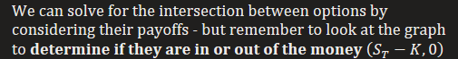
  + Rule of thumb is that for option diagrams to intersect, **one of the options has to be in the money and another out** (Otherwise they will be parallel and never intersect)

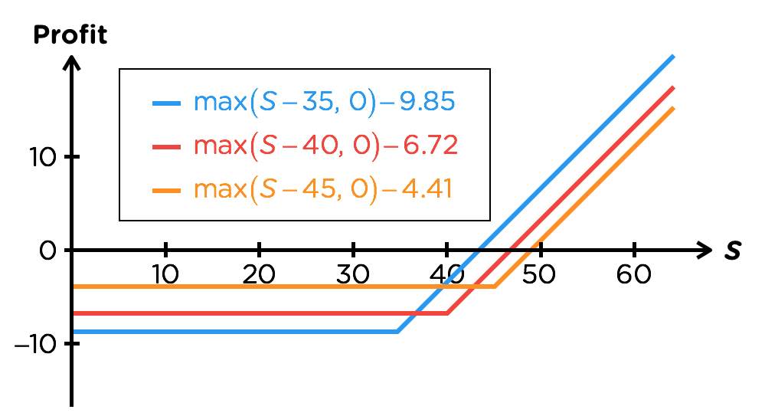



* Options kink upward from right to left
* Options move upward to reflect lower cost

# Time to expiration Condition

* 
* **American Options** with a **longer expiration can do everything** that one with a shorter expiration can and more, thus should cost more
* European Calls on a non-dividend paying assets are the same as American Calls, thus this property also applies to them as well
  + For European Calls on dividend paying assets and for all European Puts, this is ***generally true*** because a longer lasting contract should cost more
  + But there are **rare exceptions** that will violate it thus it is not a binding rule





For a non-dividend paying asset,

